ADOPT-A-FAMILY &ADOPT-A-SENIOR CITIZEN
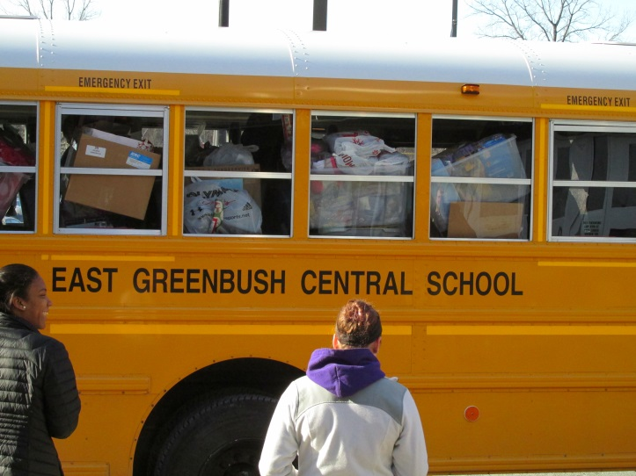
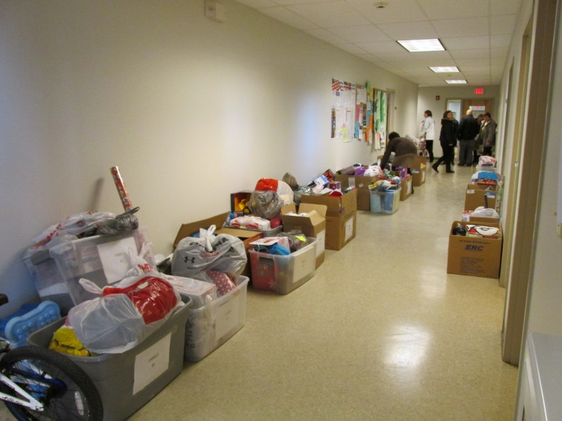 |  | HAPPY HOLIDAYS!
 | 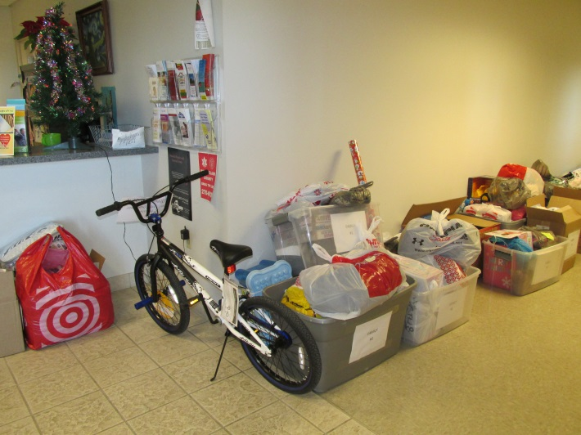

Student-Athletes from the East Greenbush Central School District this year delivered gifts for 11 families and 10 senior citizens to Rensselaer County Department of Social Service. We would like to thank the athletic families, students and community for their generous donation and support.

